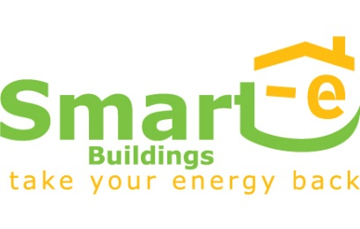
A European campaign for Smart Energy Buildings was launched in May 2011 by a consortium of leading associations, agencies and companies specialised in renewable energy, energy efficiency and sustainable communication. A major push to double or even triple the renovation rate of Europe’s buildings is necessary in order to meet Europe’s 20-20-20 goals and to reap the extensive benefits that nearly zero energy buildings bring to citizens and society alike. The campaign is supported by the Intelligent Energy Europe Programme of the European Commission.

Declaration of Support
I, the undersigned Member of Parliament, support the Smart-e Buildings’ cause and call for all of Europe’s buildings to stop wasting large amounts of energy and become completely independent from the use of non-renewable energy sources such as oil, gas, coal and uranium.
By 2050, the overwhelming majority of the building stock should be heated, cooled and operated only with renewable energies. This will happen through a smart combination of energy efficiency measures and of renewable energy supply technologies.
I, the undersigned Member of Parliament:
- Consider it imperative that the refurbishment of Europe’s buildings is prioritised in all Member States as a cost-effective way of reducing energy bills, saving carbon emissions, promoting job creation and enhancing security of energy supply,
- Am aware that technologies exist on the market today that make very smart energy buildings a real possibility already,
- Stress that smart energy buildings (new and refurbished) can enhance the widespread use of de-centralised, renewable and energy-efficient solutions,
- Underline that a critical mass in refurbishment of buildings would lead to greater affordability, increased skill levels in the workforce and invigorate an ailing European construction industry,
- Consider it crucial that the EU and Member States adopt a clear roadmap and mandatory targets for transforming Europe’s buildings into smart power houses over the coming decades,
- Emphasise the need for the public sector to take the lead in advancing the way towards smarter buildings,

Date: | Name:
Function (MP/MEP): | Country:
Party: | Signature:

EREC (European Renewable Energy Council), EuroACE (European Alliance of Companies for Energy Efficiency in Buildings), CEETB (European Energy Efficiency Installers – Committee for the Construction Industry), FEDARENE (European Federation of Regional Energy and Environment Agencies), Energy Cities (Association of European local authorities inventing their energy future), Climate Alliance (Association of European local authorities committed to climate protection), ADEME (French Environment and Energy Management Agency), eclareon, Ketchum Pleon.
. The sole responsibility for the content of this document lies with the authors. It does not necessarily reflect the opinion of the European Union. Neither the EACI nor the European Commission is responsible for any use that may be made of the information contained therein.

